RN2025.01-EZ-Upheaval-2020-2024

Table of Contents

1. Introduction 2

2. Observations 3

2.1 Catalogs and Analysis 3

2.2 Maps 5

3. Photometry 6

4. Limb Modeling and Correction 7

4.1 Absorption Profiles 7

4.2 Ammonia Abundance and Cloud Top Profiles 9

5. NEBs/EZn Dark Features and Plumes 11

5.1 Population Analysis 12

5.1.1 2022-23 Apparition 13

5.1.2 2023-24 Apparition 14

5.2 Specific Examples 15

5.2.1 2023-08-30 15

5.2.2 NEDF Between 185-225 deg (Sys 1) Aug 27 - Oct 06 17

5.2.3 2023-10-06 20

5.2.4 2023-11-13 22

5.3 Meridional Profile Trends 26

6. GRS and evolution in 2022-2023 29

7. Meridional Profile Changes with Time 33

References 33

# Introduction

What is the right nomenclature I’m looking for?

First brought to my attention in fall of 2024 by Glenn Orton when he shared 5μm data. However, I had noticed late in the 2023-24 season that peak ammonia mole fraction seemed to have moved southward in the EZ from the 2022-23 season. At the time, I don’t think I recognized the significance of this.

At glance, it looks like the NEB underwent an expansion between 2023 and 2024 also. Might this be a global upheaval?

|  |  |
| --- | --- |
|  |  |

Figure : Clearing in the EZ and the NEBn is evident in Pcloud meridional profiles between 2023 and 2024 in the amount of about 80mb using the simple RLM model and VLT/MUSE calibration from 2022. The profile half-width is 2°.

|  |  |
| --- | --- |
|  |  |

Figure : The peak ammonia mole fraction shows a shift to the south in the EZ, while the general profile seems to indicate a decline in the global average abundance. However, the latter may be due to the dependence on the 2022 VLT/MUSE calibration. The profile half-width is 2°.

ISSUE: Longitude map alignment may have a problem at the 1-2 deg level. This may be due to using integer latitudes to ‘roll’ the arrays when converting from one longitude system to another.

# Processing

# Observations

Need to have a good section on observations, catalog analysis, and synoptic maps. Foreign key for the DB needs to be YYYYMMDDxNN with x being a letter to indicate the observation on the given UT data and maybe having NN as a two digit number indicating the version of the processed data – this would include variations and parametric studies.

## Catalogs and Analysis

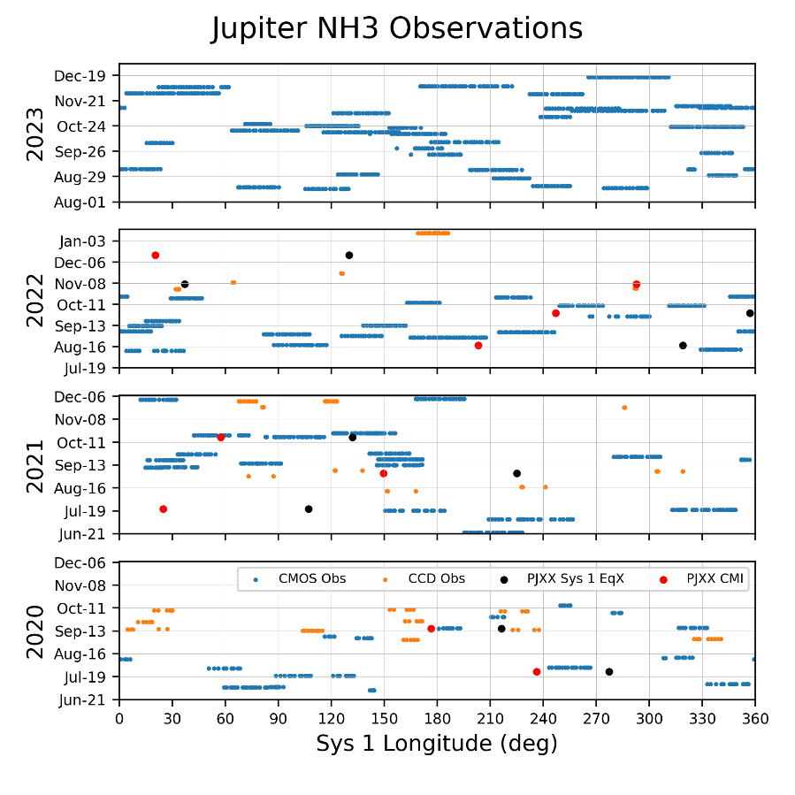

Figure : Catalog.png produced by PlotJupiterObservations in JupiterObservationCatalog.py

ISSUE: Need to add Juno perijoves for 2023. It would also be good to add or distinguish other professional observation events, like VLT-MUSE, JWST, 5um, and HST.

ISSUE: Should highlight times and longitudes of specific weather events from John Rogers

ISSUE: Need to add 2024-25 data

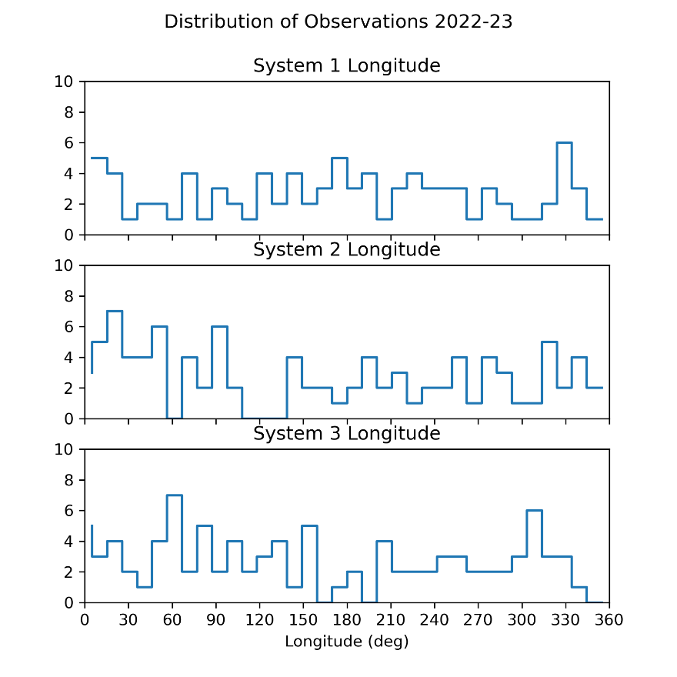

Figure : Catalog_Hist.png produced by Catalog_Analysis.py. This code also produces catalog.csv and catalog.json files with records for each observation. For this analysis, bins are 10 deg wide yielding a total of 36 bins. This kind of analysis is good for identifying longitudes that are good candidates for studying over time.

ISSUE: A good approach would be to not have fixed bins, but to identify observations that cluster around similar longitudes.

ISSUE: There’s a legacy catalog code, JupiterObservationCatalog, in JupiterObservationCatalog.py that looks at individual filters used, and images taken (I think). This needs to be updated or deprecated.

## Visual Browsing – ‘Standard’ Images, Maps, and Synoptic Maps

* ISSUE: Need to aggregate dates for contiguous maps. Done for 2022 and 2023
* ISSUE: Need to update readme files for the file naming convention – adding Img and Map to the file names.

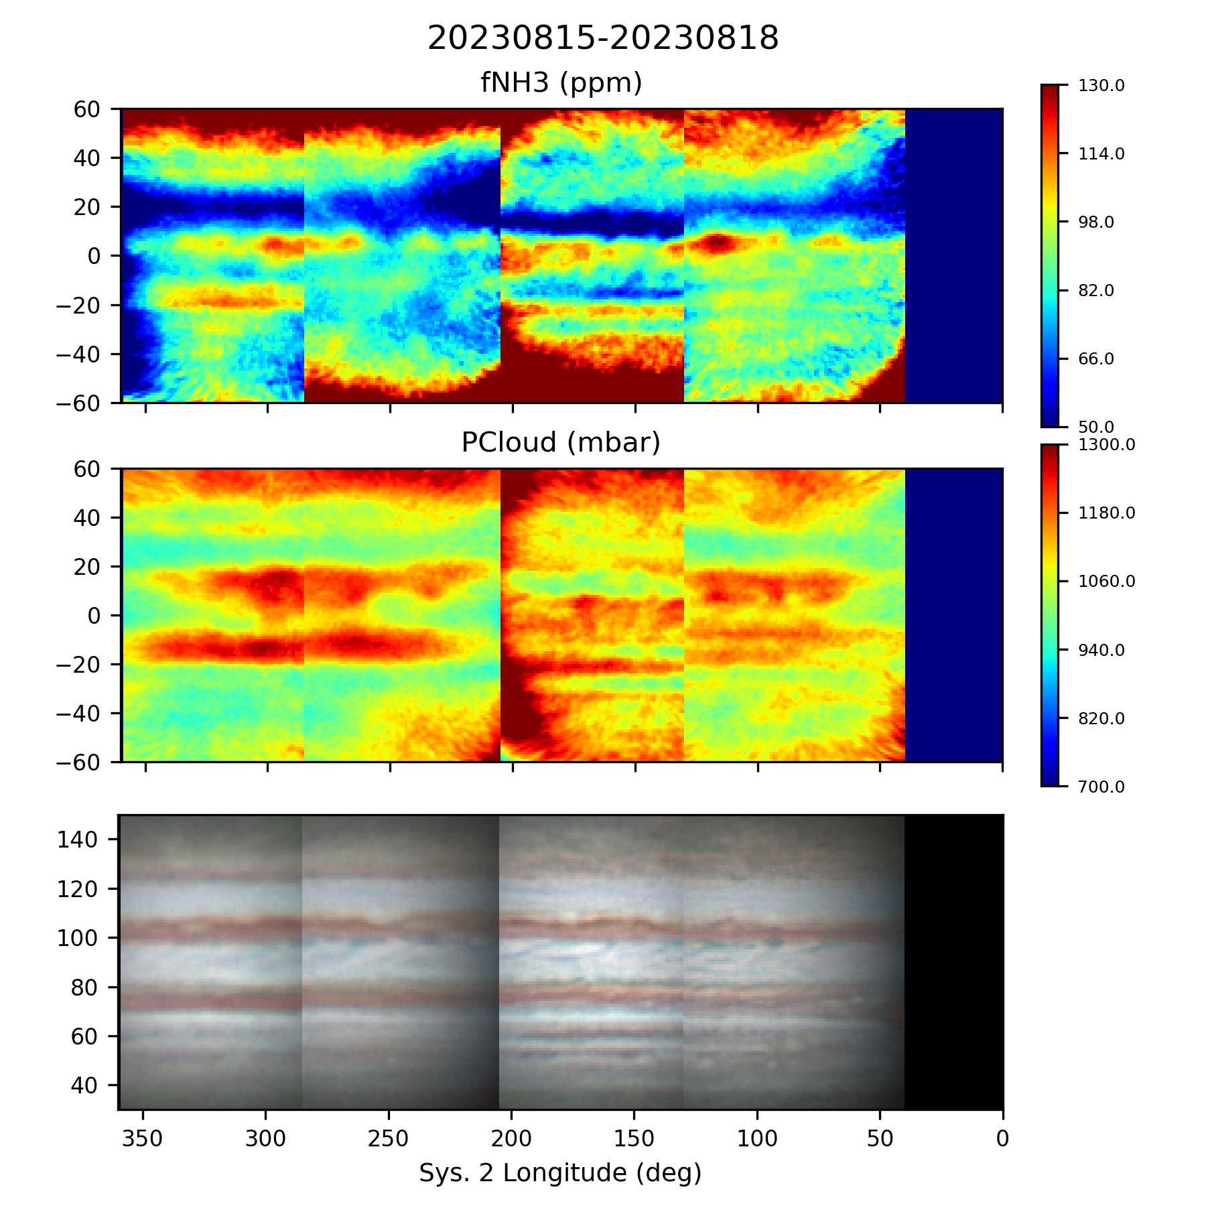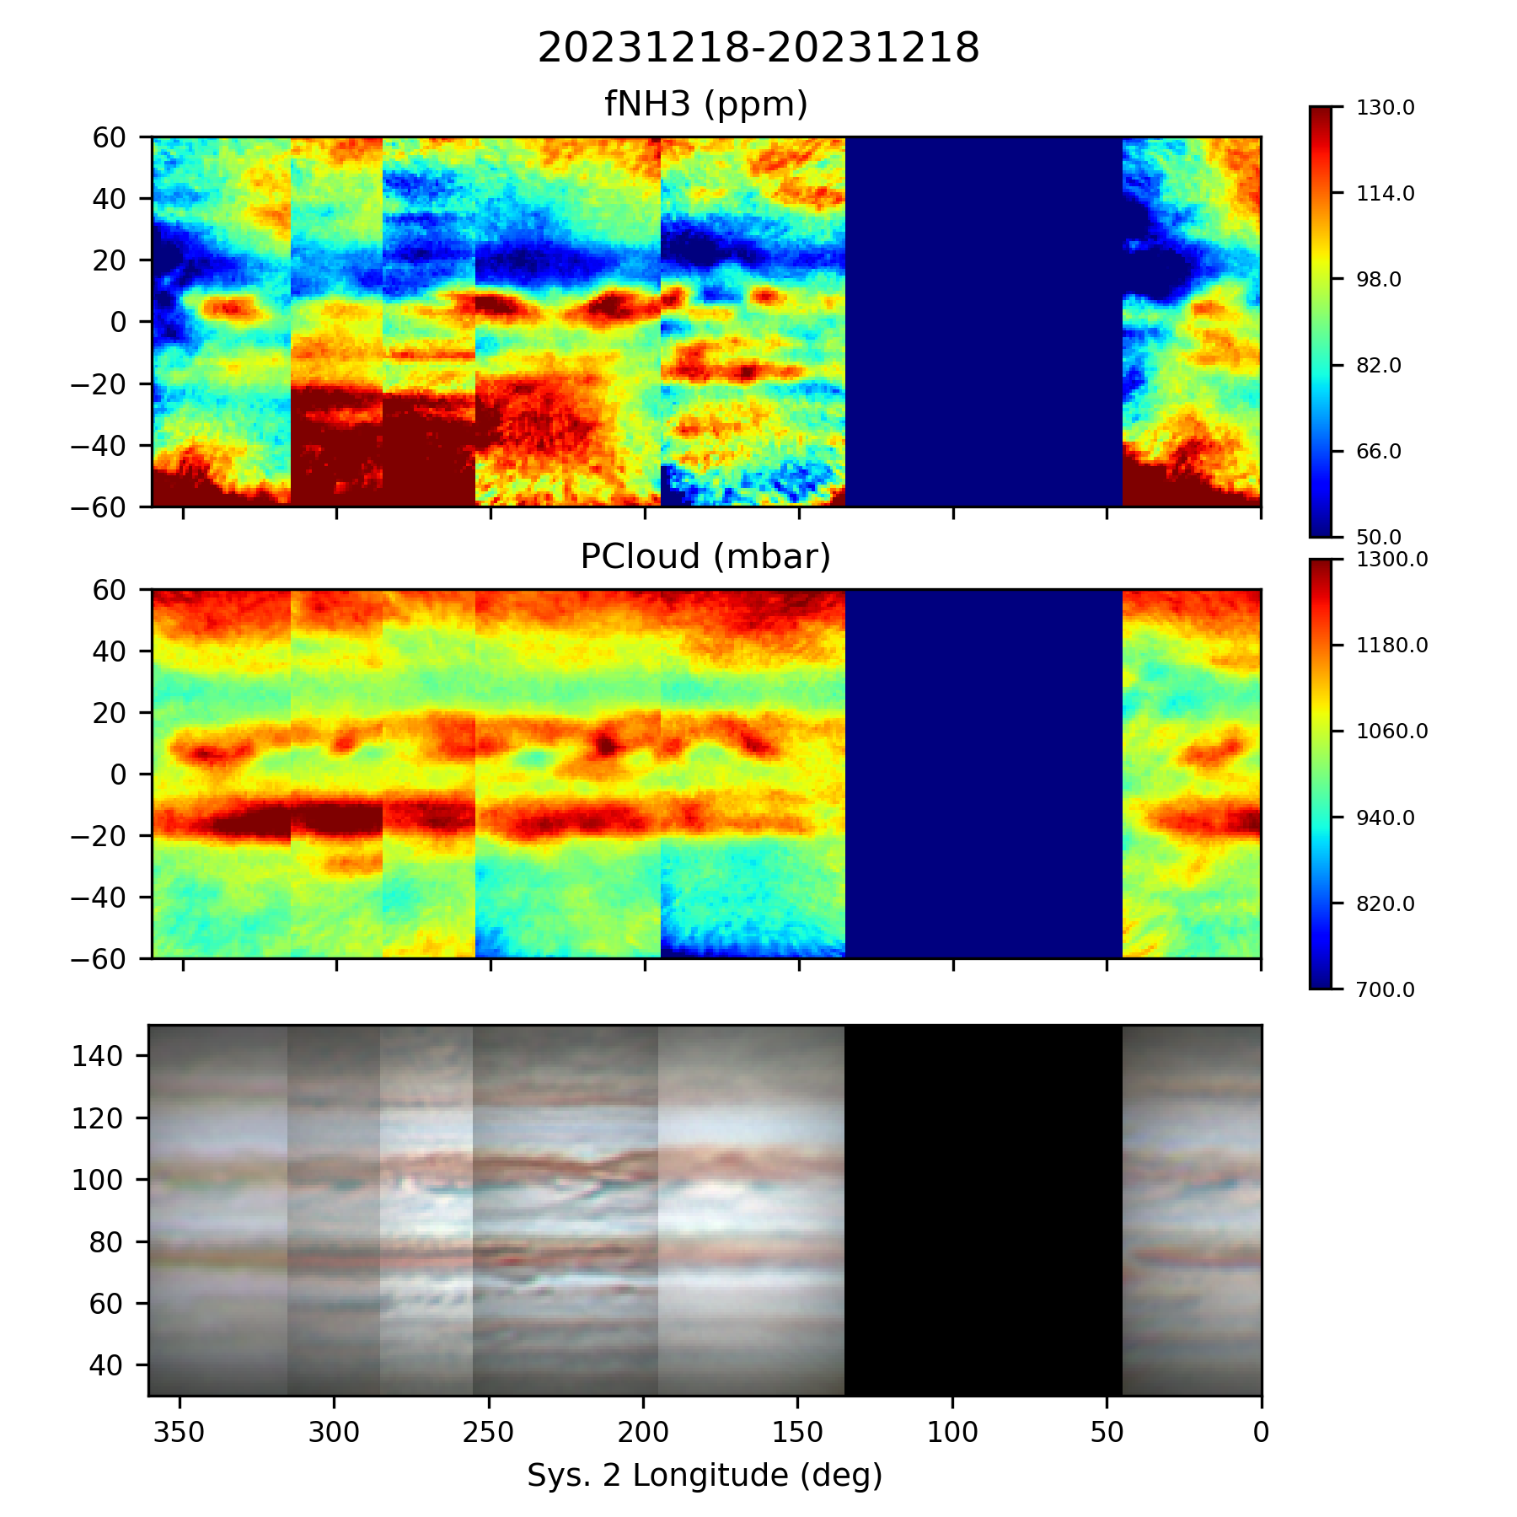

# Limb Modeling and Correction

* ISSUE: Need to process 2020 and 2021 absorption data according to 2022-23 standard pipeline Done in 2024.

## Absorption Profiles

A few observations about meridional profiles:

* Significant decrease in absorption in *both* bands at the boundary for the STB and STrZ.
* Significant increase in CH4 absorption from the NEB to the NNTB with peaks a the NEB-NTZ boundary and the NTZ-NNTB boundary. Ammonia absorption stayed mostly the same in those regions.

|  |  |
| --- | --- |
|  |  |
|  |  |

Figure : Meridional profiles of NH3 and CH4 absorption (top and bottom respectively). Meridional width is ±5 deg of the central meridian. No smoothing is performed.

ISSUE: Need to add labeling for smoothing and width like for parameter plots.

A few observations about zonal profiles:

* The ammonia profile is mostly unchanged from 2022 to 2023.
* The methane profile seems to show an increase in absorption toward the limbs in 2023.

|  |  |
| --- | --- |
|  |  |
|  |  |

Figure : Zona profiles of NH3 and CH4 absorption (top and bottom respectively). Zonal width is ±5 deg of the equator. No smoothing is performed.

## Ammonia Abundance and Cloud Top Profiles

A few observations about ammonia abundance and cloud-top pressure in meridional profiles:

* Ammonia shows an increase in the NEZ and the NEB. Could this be correlated with the modest decrease in cloud pressure?
* Ammonia shows a modest increase in in the SEB also, but there is no meaningful change in cloud pressure.
* There is a sharp decrease in cloud pressure from the SEZs to the SSTB with no notable change in ammonia.
* There is a sharp increase in the cloud pressure from the NEBn through the NTZ. In these regions ammonia show no significant changes.

|  |  |
| --- | --- |
|  |  |
|  |  |

Figure : Meridional profiles of fNH3 and PCloud (top and bottom respectively). Meridional width is ±5 deg of the central meridian. No smoothing is performed.

A few observations about ammonia abundance and cloud-top pressure in zonal profiles:

* Ammonia is mostly unchanged from 2022 to 2023.
* Effective cloud top pressure seems to have decreased toward the limb in 2023 versus 2022.

|  |  |
| --- | --- |
|  |  |
|  |  |

Figure : Zonal profiles of fNH3 and PCloud (top and bottom respectively). Meridional width is ±5 deg of the central meridian. No smoothing is performed.

# NEBs/EZn Dark Features and Plumes

I am investigating the spatial relationship between ammonia enhancements, deep clouds represented by significant CH4 absorption in the 619 nm band, and dark formations (projections) recorded by WINJupos measurers. The work is motivated by multiple researchers’ work showing enhancement and depletion in plumes and ‘hot spots’ in the northern EZ (NEZ) <<<CITATIONS>>>

With 66 observations (2022 SCT: 19; 2022 VLT: 2, 2023: 45) through Nov 28, 2023 containing >291 measurements of deep clouds / dark formations (145) and NH3 enhancements (146)

Table : Summary of Observations and Measurements for Hot Spots and Ammonia Enhancements through 12/17/2023.

|  |  |  |  |  |
| --- | --- | --- | --- | --- |
|  | 2022 SCT | 2022 VLT | 2023 SCT | Total |
| Observations | 19 | 2 | 45 | 66 |
| Nights observed |  |  |  |  |
| Cloud Holes |  |  |  | 175 |
| NH3 Enhancements |  |  |  | 180 |
| Total Measurements |  |  |  | 355 |
| WINJupos Measurments between 6/1/2022 and 11/24/2023 |  |  |  | >7000 |
|  |  |  |  |  |

Measurements of NEZ ammonia enhancements and CH4 hot spots, we now have the ability to look at the statistics of this population. The results show an offset to the southeast that seems compatible with [*Choi et al.*, 2013] and enhancements being associated with anticyclonic gyres.

Downloaded all measurement files from WINJupos website <http://jupos.privat.t-online.de/index.htm> and placed them under C:\Astronomy\Projects\Planets\Jupiter\WINJupos Measurements Downloaded.

Created an area for conducting studies C:\Astronomy\Projects\SAS 2021 Ammonia\Jupiter_NH3_Analysis_P3\Studies\Dark Features which contains all the WINJupos selection and drift chart files for this effort. I also created a new measurement file, Hill_ammonia.mea, specifically for measuring the position of phenomena from my ammonia data. The WS are ammonia enhancements and the DS are deep clouds (high pressure) seen in CH4. Note that there appear to be some dates with quality issues associated with differential sharpness.

I created a directory for all the System on maps C:\Astronomy\Projects\SAS 2021 Ammonia\Jupiter_NH3_Analysis_P3\Analysis Data\L3 Plots\Dark Features and batch created them for 2022-23 (though 2023 data has not yet been completely reduced). I then ran the maps for 2022 one-by-one to use the interactive Python interface to determine the centroids of the NH3 and CH4 features. This was done by visual inspection and manually entered into the measurement file. All the data analyzed here is uncorrected and unsmoothed.

## Population Analysis

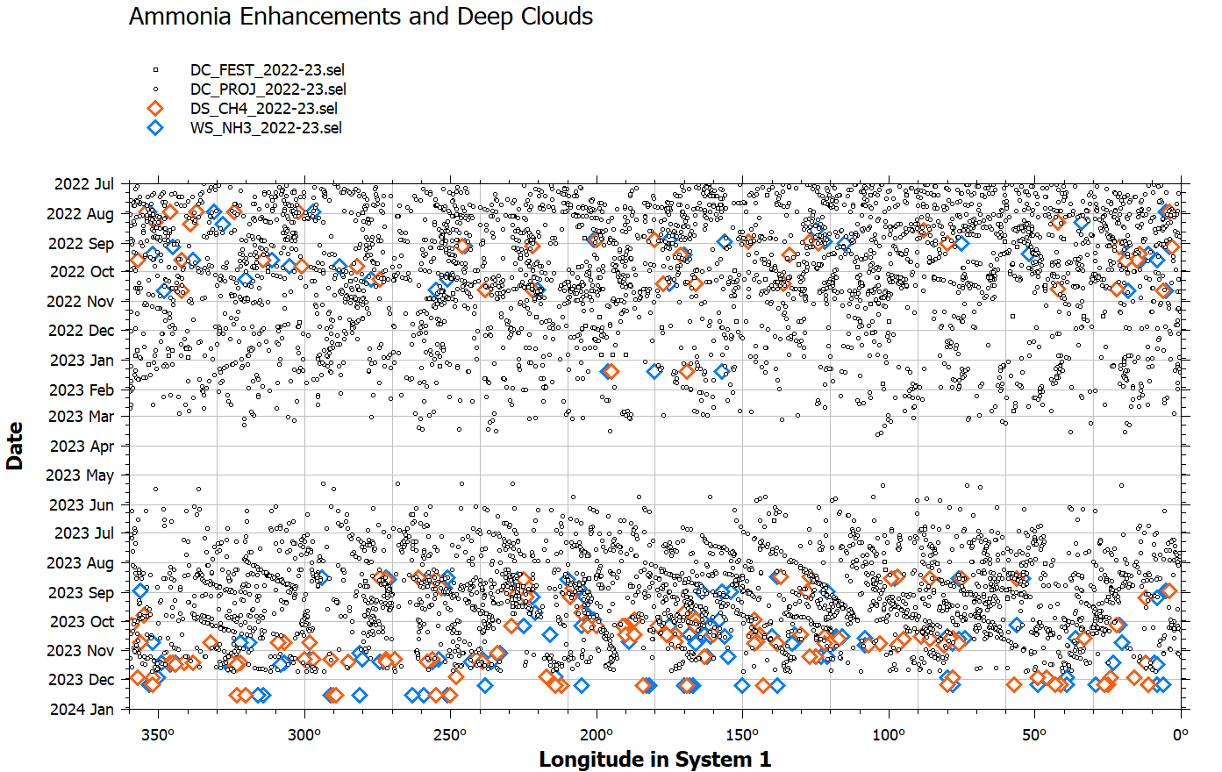

DC_PROJ_FEST_2022-23.png

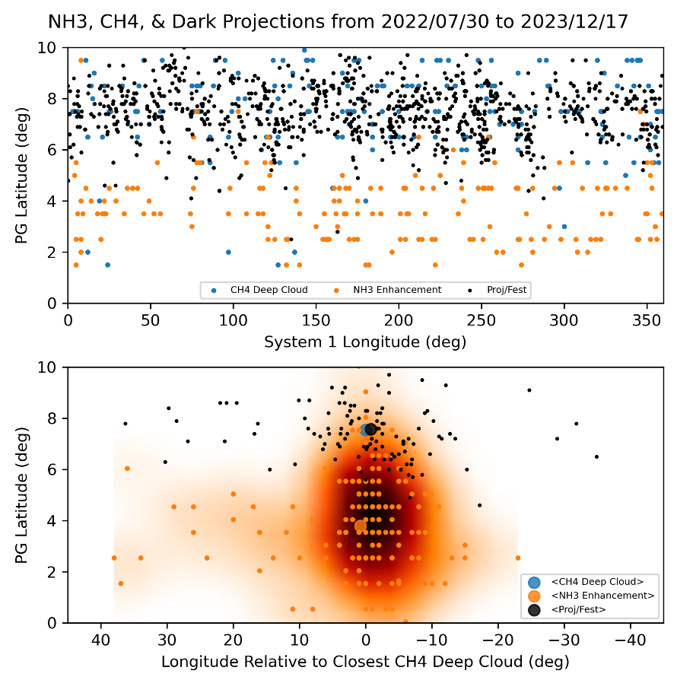

nez_analysis.png updated last on 2/3/2024. Update is through 12/16/2023.

NH3 enhancements are 1.05 deg south and 3.5 deg east of deepest CH4 cloud locations.

Relevant work on circulation and meteorology in an around dark formations [*Choi et al.*, 2013]. There’s good info on hot-spot dynamics in several sections of the paper and their relevance to ammonia. Location of my NH3 enhancements suggests that they are near the anticyclonic gyre to the south-southeast of the dark formations.

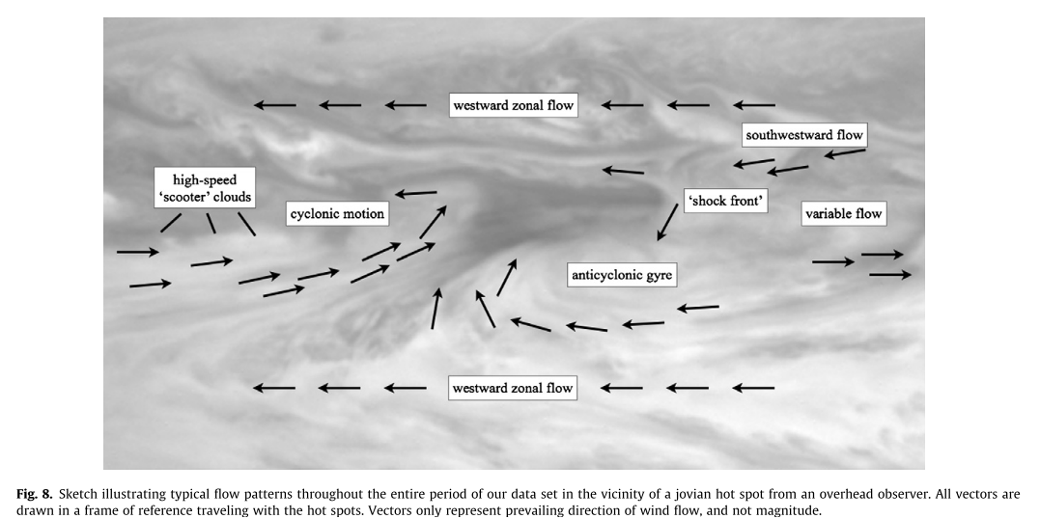

### 2022-23 Apparition

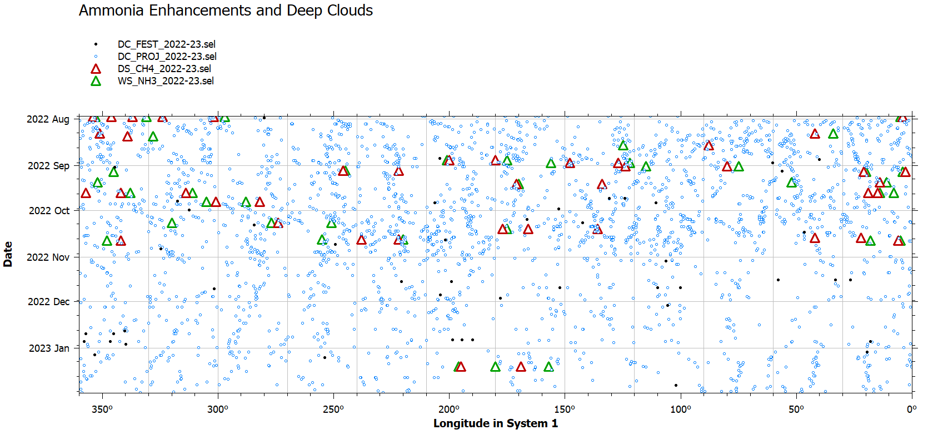

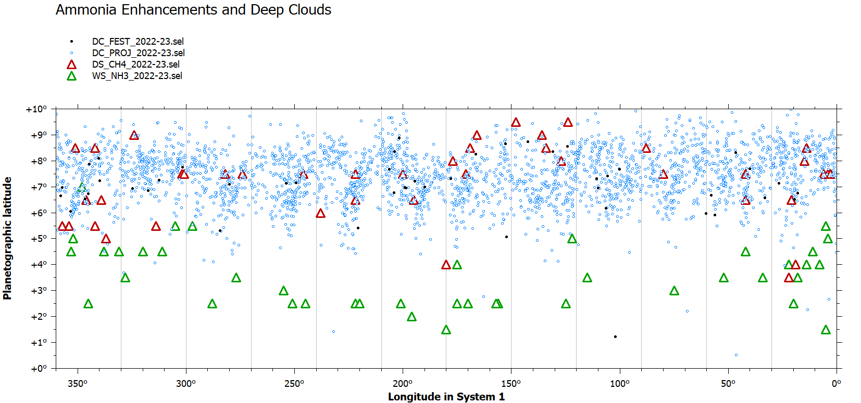

### 2023-24 Apparition

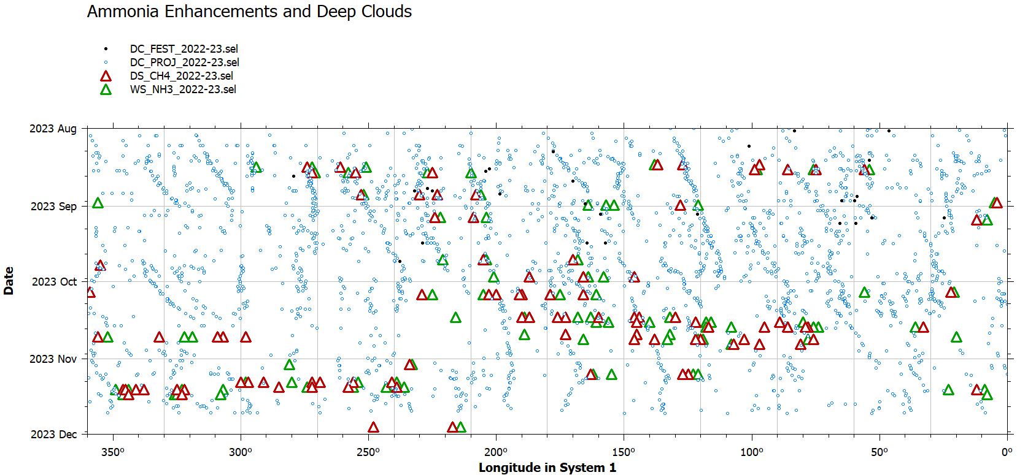

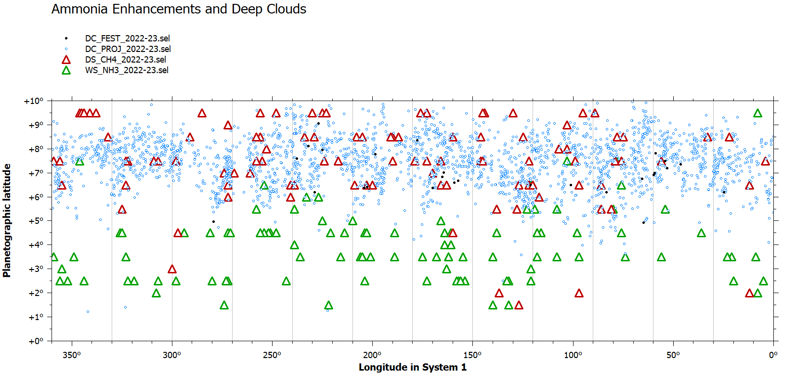

## Specific Examples

0818

0827

### 2023-08-30

|  |
| --- |
|  |
|  |
|  |

### NEDF Between 185-225 deg (Sys 1) Aug 27 - Dec 18

Filtered between 175 and 235 Sys 1 longitude for the CM of the observation.

|  |  |  |  |  |
| --- | --- | --- | --- | --- |
| **ObsID** | **NH3 Time** | **CM1** | **CM2** | **CM3** |
| 20230827UTa | 2023-08-27_11:30:36 | 218.6 | 159.5 | 179.1 |
| 20230827UTb | 2023-08-27_11:53:48 | 232.7 | 173.6 | 193.2 |
| 20230905UTa | 2023-09-05_11:38:18 | 204.8 | 77.1 | 99.1 |
| 20230905UTb | 2023-09-05_12:05:12 | 221.2 | 93.3 | 115.4 |
| 20230922UTa | 2023-09-22_06:29:00 | 182 | 286.1 | 312.6 |
| 20231006UTa | 2023-10-06_05:04:42 | 182.8 | 180.6 | 210.8 |
| 20231006UTb | 2023-10-06_05:35:24 | 201.5 | 199.1 | 229.3 |
| 20231015UTb | 2023-10-15_05:22:36 | 176 | 105 | 137.6 |
| 20231207UTa | 2023-12-07_02:48:18 | 176 | 61.5 | 108.2 |
| 20231207UTb | 2023-12-07_03:14:48 | 192.2 | 77.5 | 124.2 |
| 20231207UTc | 2023-12-07_03:43:42 | 209.8 | 95 | 141.7 |
| **20231218UTf** | **2023-12-18_05:13:06** | **201.2** | **1.9** | **51.5** |
| **20240129UTa** | **2024-01-29_02:07:00** | **235** | **76.3** | **137** |
| **20240131UTa** | **2024-01-31_02:22:30** | **199.9** | **25.9** | **87.1** |
| **20240131UTb** | **2024-01-31_02:49:06** | **216.1** | **41.9** | **103.2** |
| **20240202UTb** | **2024-02-02_03:19:30** | **190** | **0.5** | **62.3** |

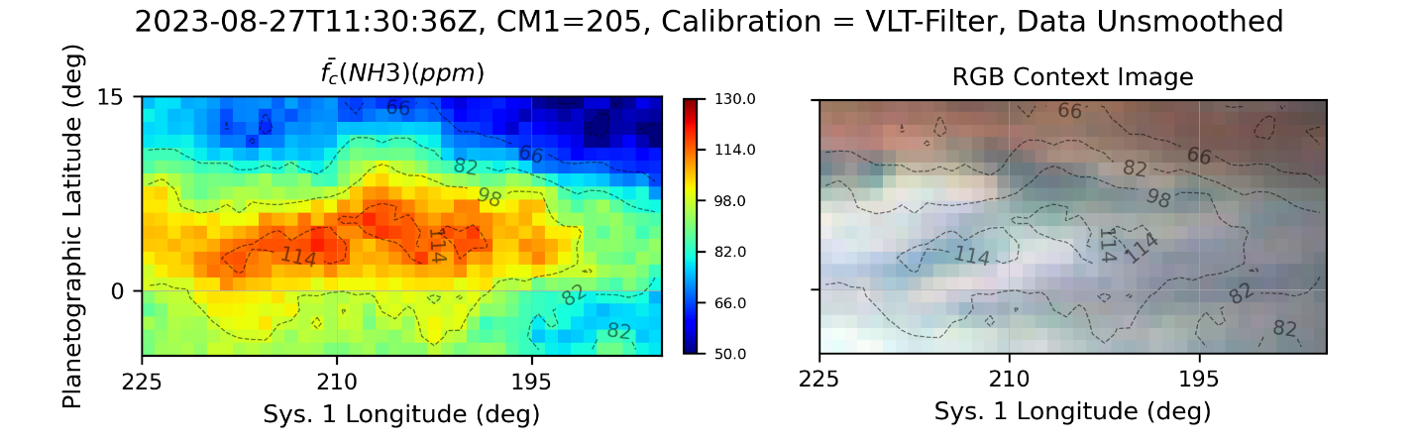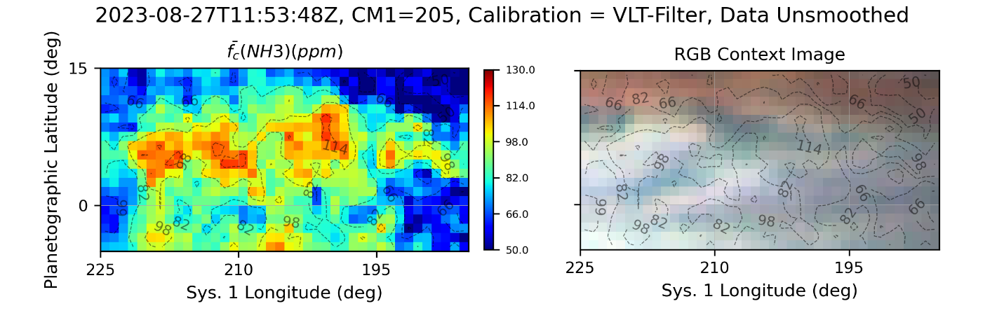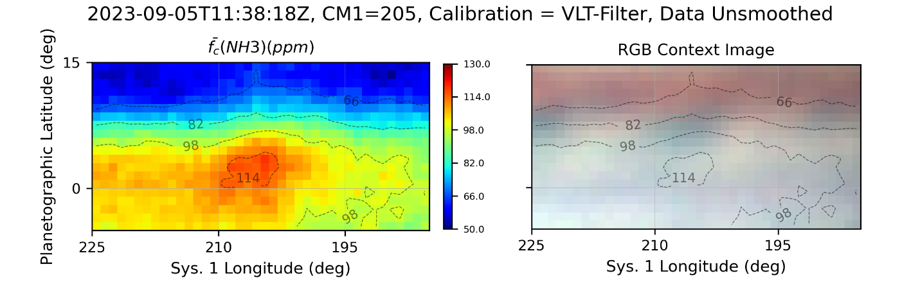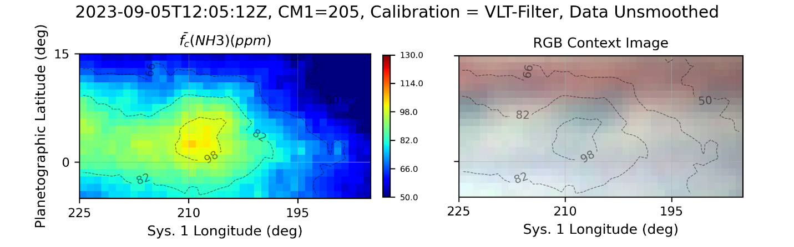

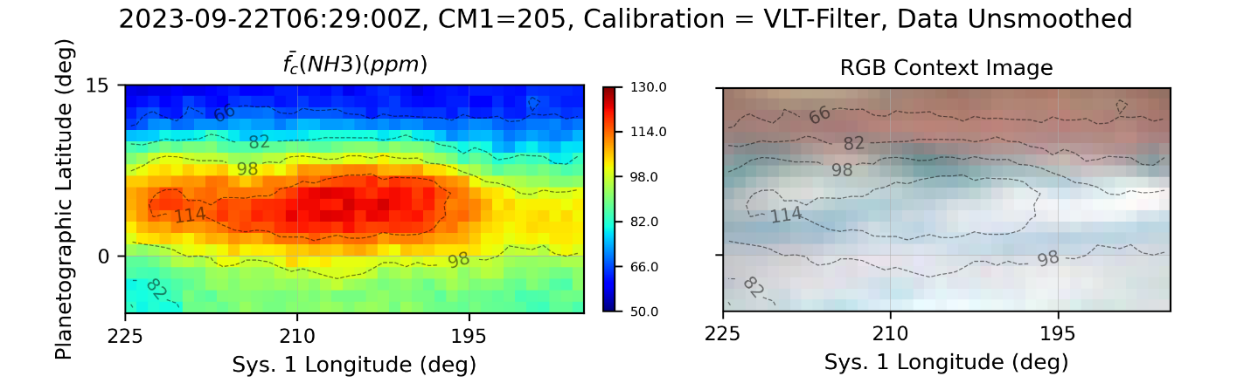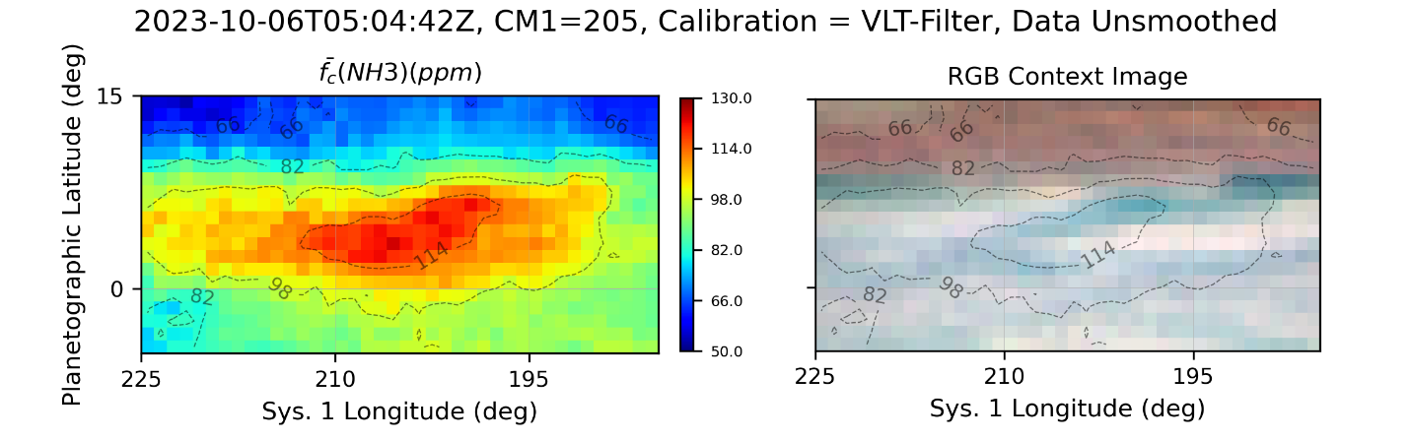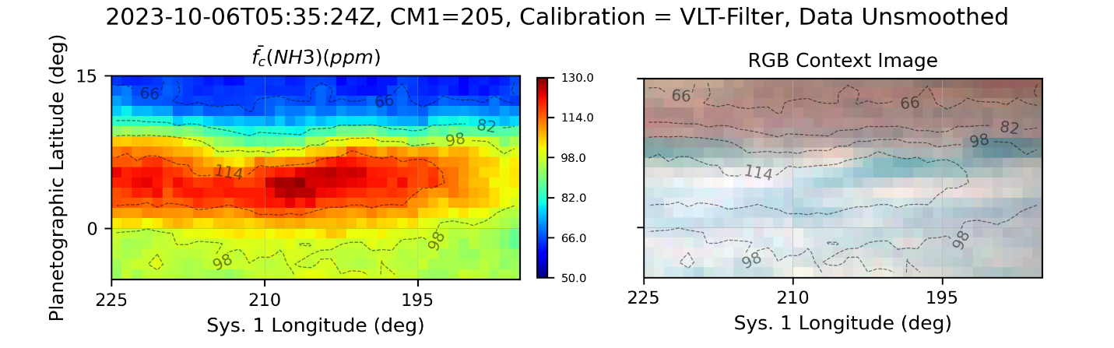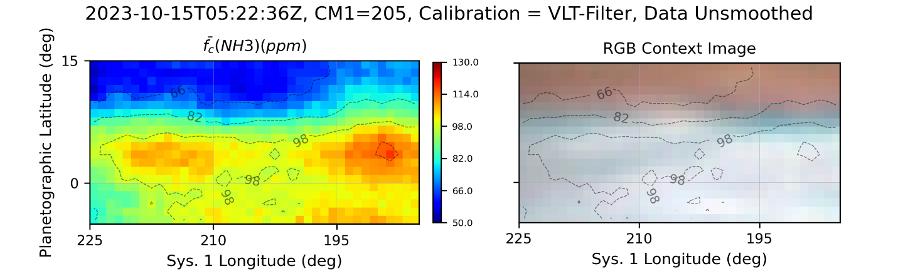

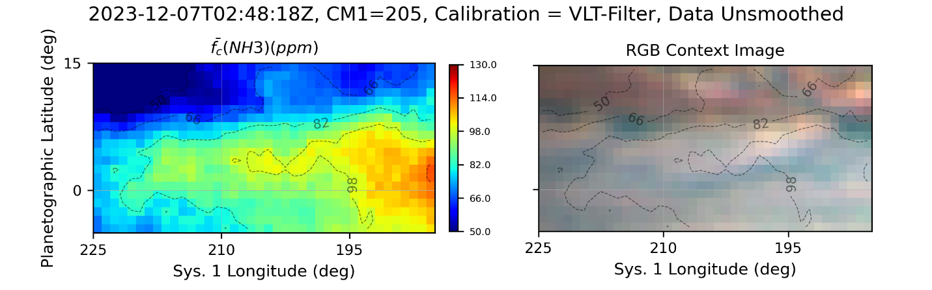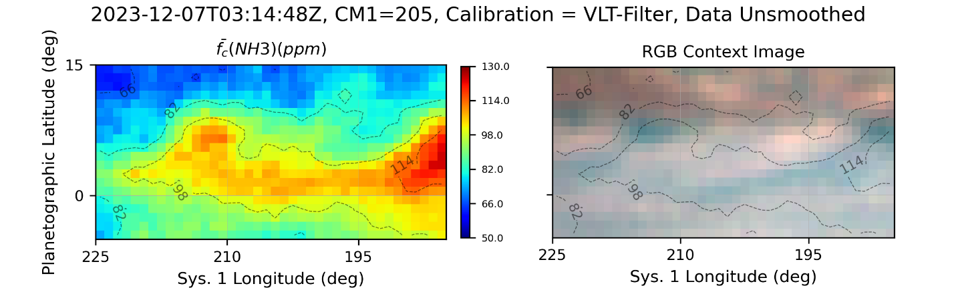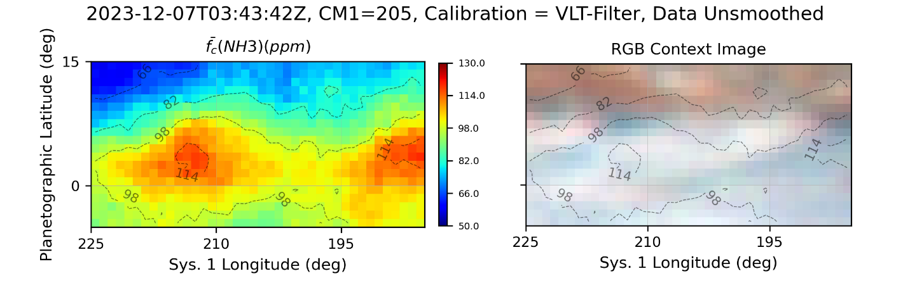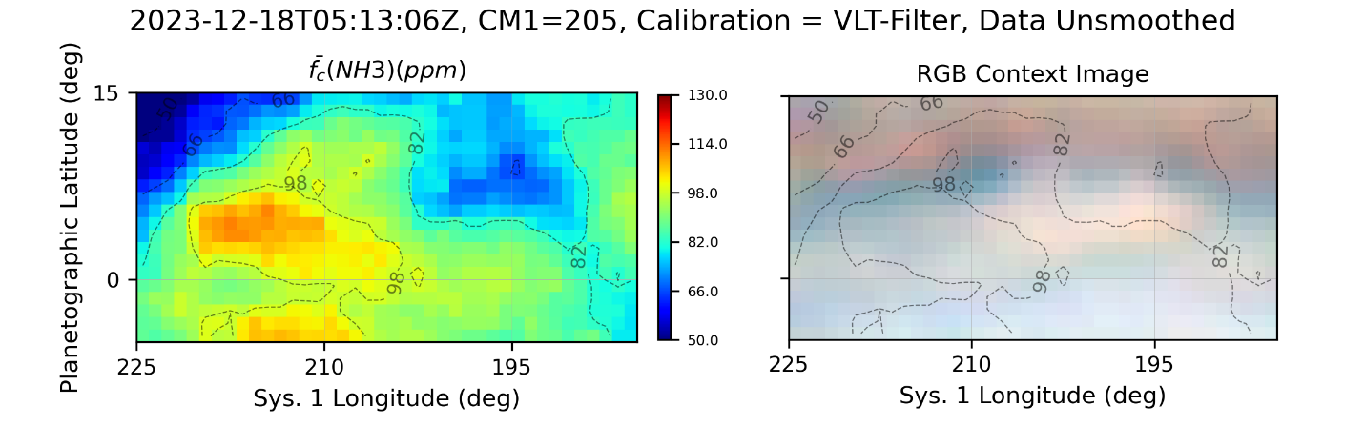

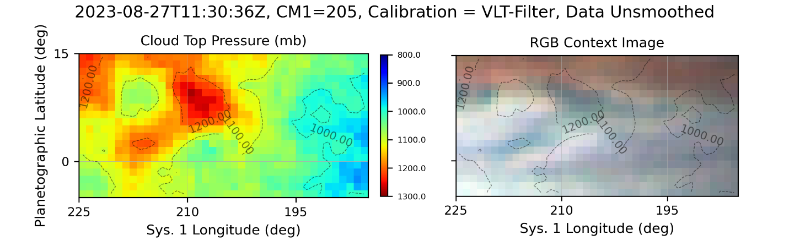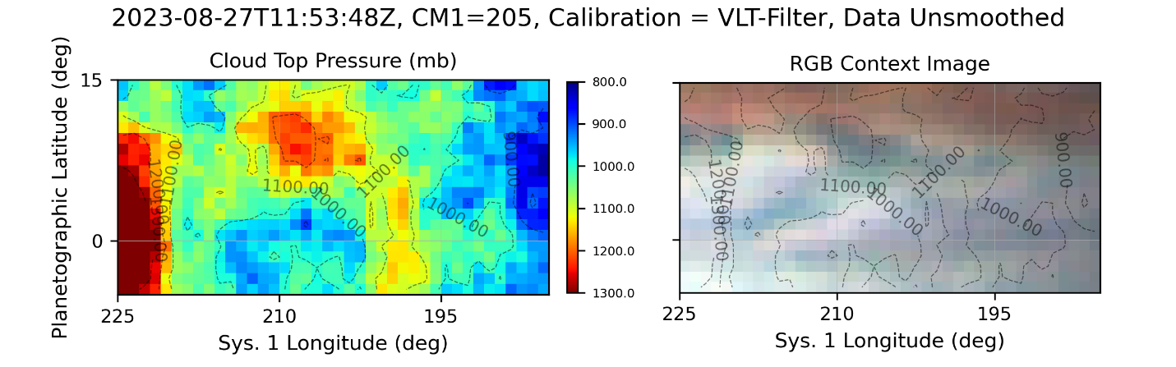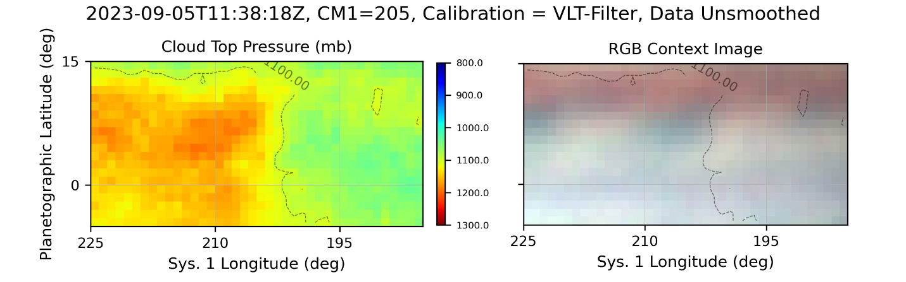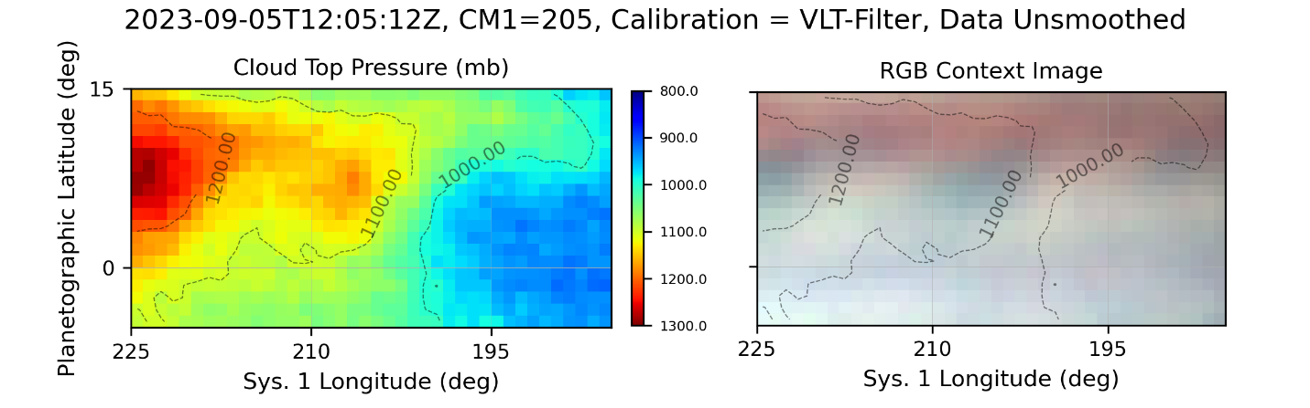

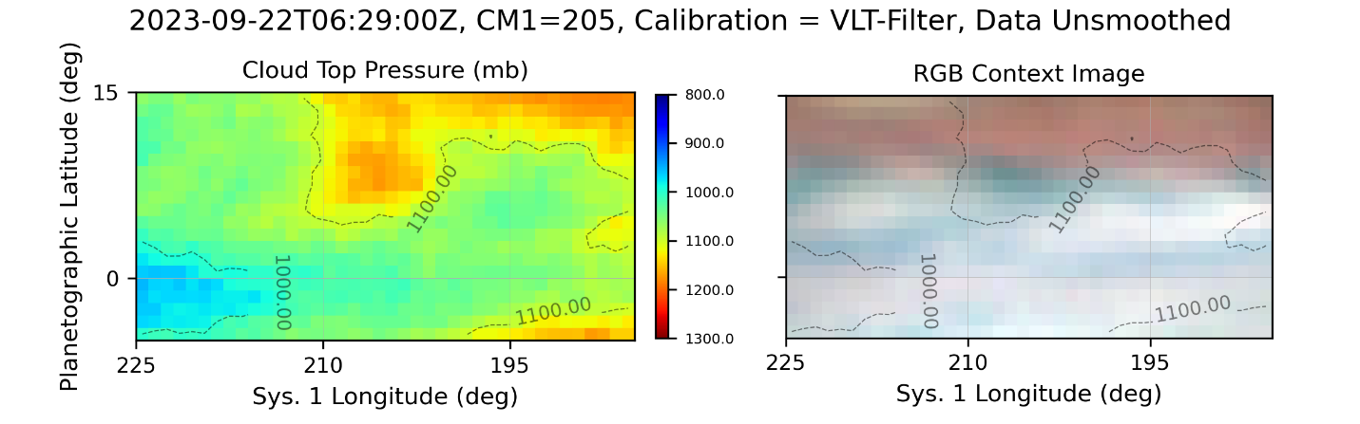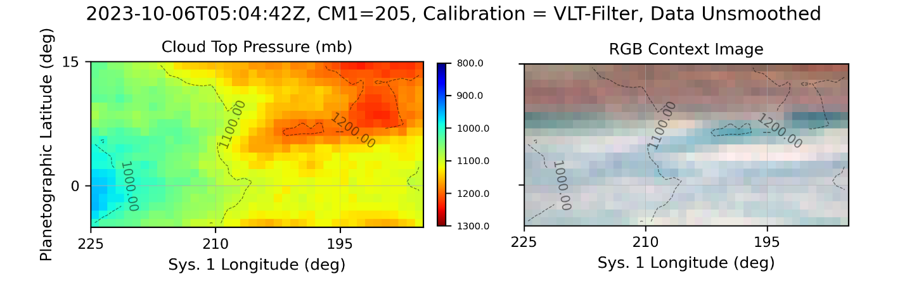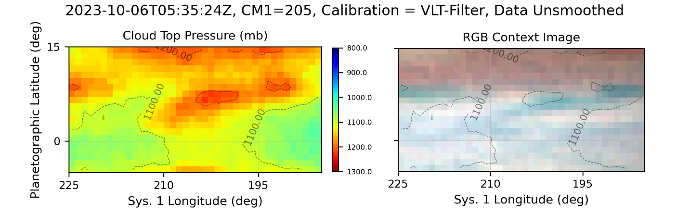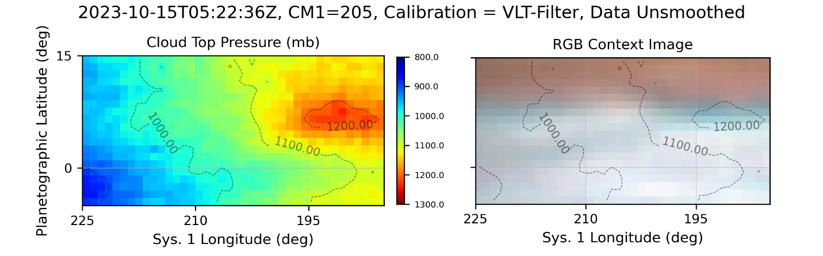

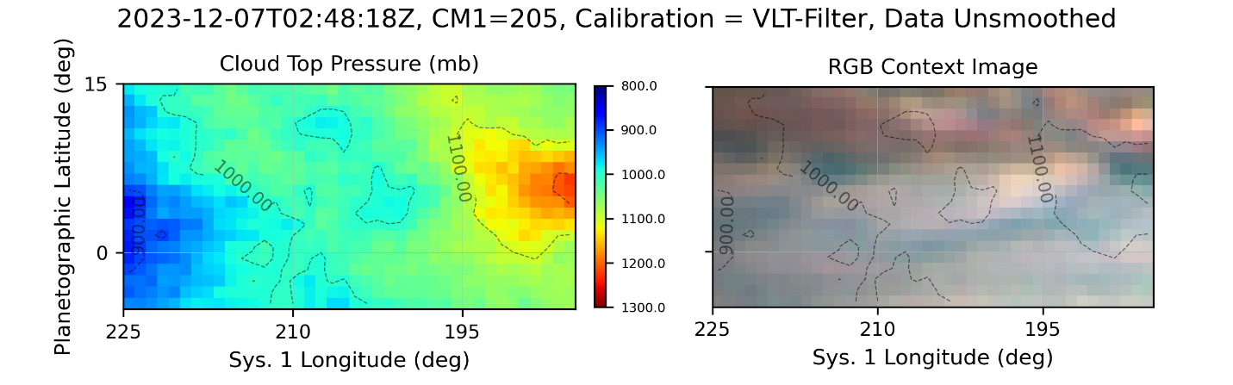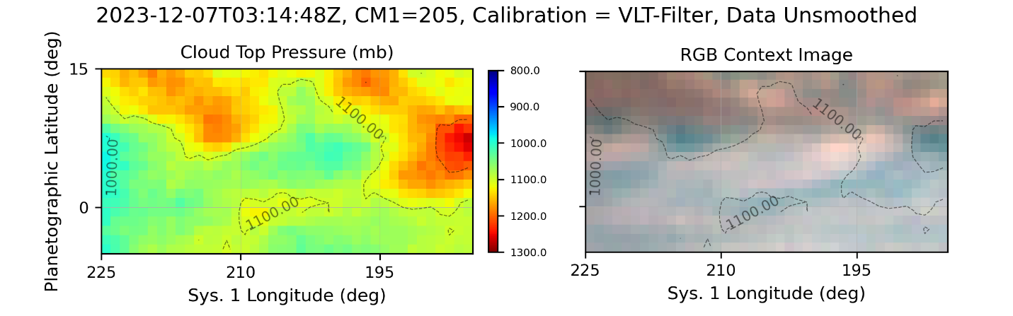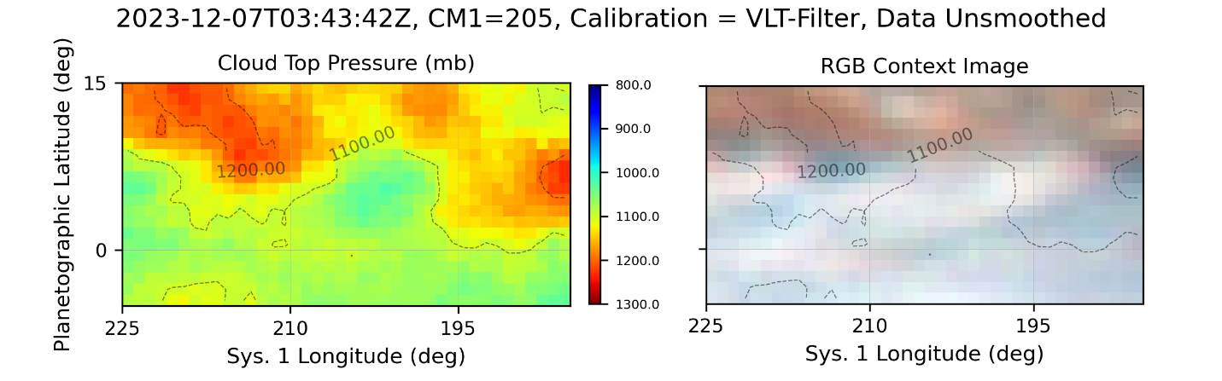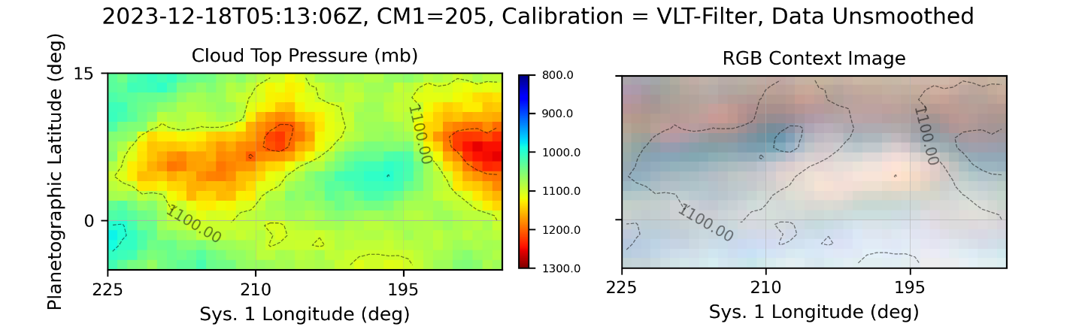

|  |
| --- |
|  |
|  |
|  |
|  |

### 2023-10-06

|  |
| --- |
|  |
|  |
|  |

### 2023-11-13

|  |
| --- |
|  |
|  |
|  |

|  |
| --- |
|  |
|  |
|  |

|  |
| --- |
|  |
|  |
|  |

|  |
| --- |
|  |
|  |
|  |

9/29/2023

10/05/2023

10/06/2023

10/15/2023 – low resolution on a, good on b

10/17 – maybe

1019b

1024 – saturation?

1107a

1110

## Meridional Profile Trends

It appears that in early 2024 the EZ ammonia enhancements began a migration southward. By the end of January were straddling the equator. This is particularly evident in the 2024-01-31 observations (most recent processed as of 5/21/2024). Is it coincident with the appearance of a strong, relatively narrow bright (sub-) zone in the EZ just south of the equator (1-5 deg S)? This zone is visible as early as August 2023, but seems to have periods of enhanced definition in 2024. During 2023, there are periods when the zone does not seem to completely circumscribe Jupiter’s equator or is somewhat chaotic. What is the correlation?

* Look at L2 and L3 profiles and changes over time.
* Look at latitude drift of discrete NH3 enhancements over time.
* Look at degree of condensation and intensity of NH3 enhancements over time.
* Look at degree of condensation and intensity of NEDFs and/or CH4 deep clouds over time
* Review Jupiter Section reports on EZ.

Hi John and Pat,

As I’m working through my observations from 2022-2024, I’ve come across a potential change I wanted to run by you. It appears to be me that the NEZ ammonia enhancement has decreased from August 2023 to January 2024. During January (-March?) of 2024 it appears that EZ ammonia enhancement has become more diffuse and is occurring at or southward of the equator. At the same time, a narrow, bright (sub-) zone (1-5 deg S) within the SEZ appears more pronounced to me than earlier in the apparition. Earlier, it appeared less bright, sometime discontinuous, and sometimes even chaotic.

John, I’m wondering if you concur with my observation regarding the appearance of the SEZ. (I need to review BritAstro Jupiter reports to see what’s already been described.)

Pat, I’m wondering what your thoughts are regarding the possible correlation between the visual changes (if correct) and the shift in ammonia enhancement to the south.

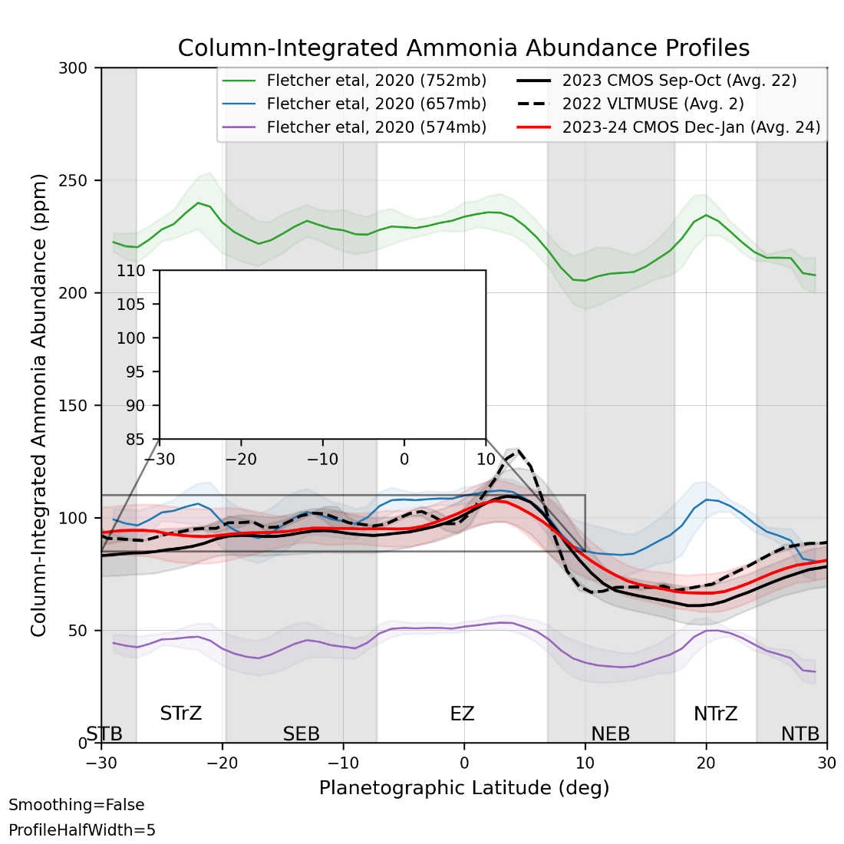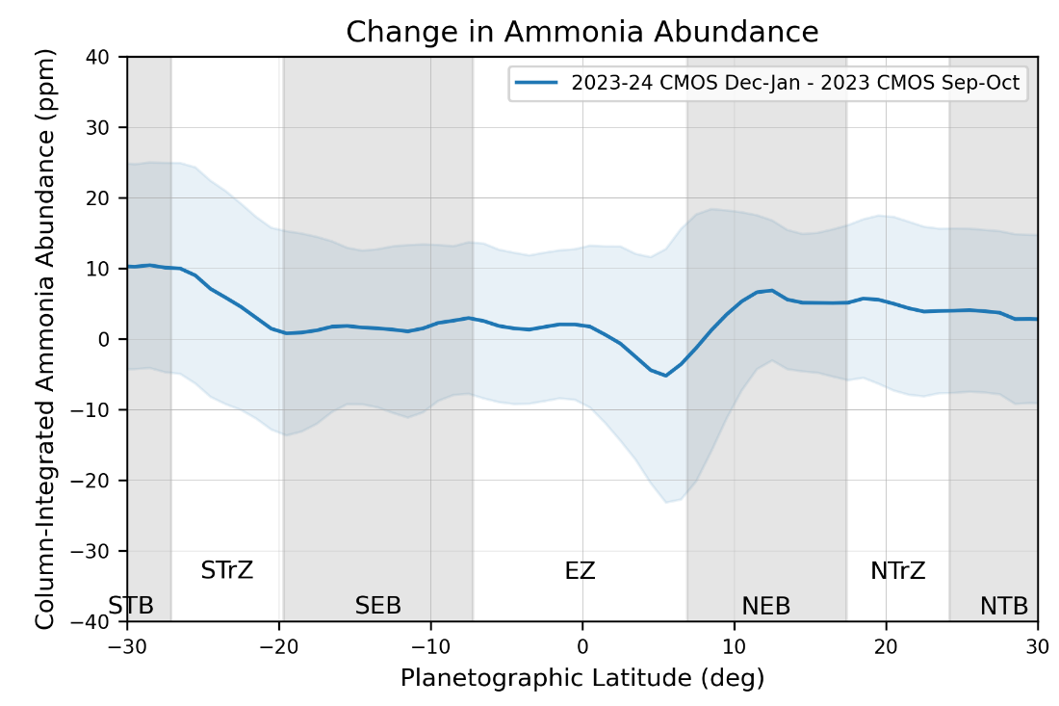

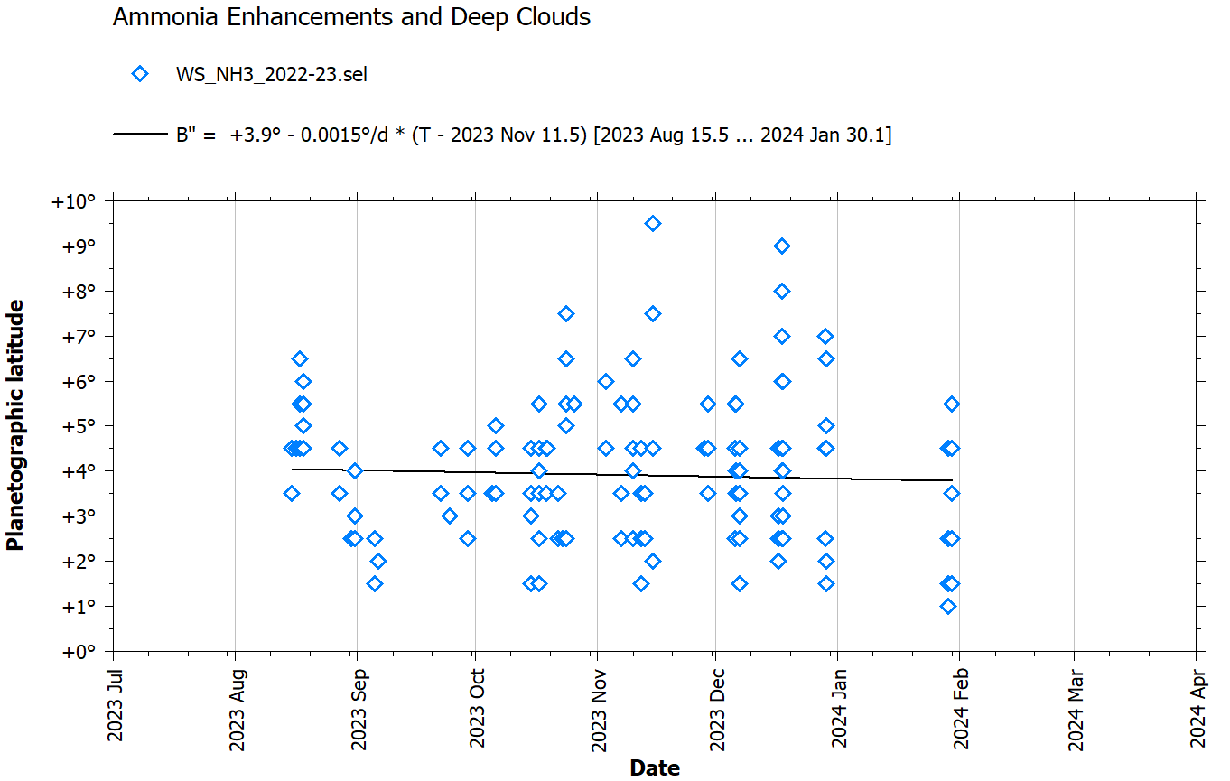

# GRS and evolution in 2022-2023

Table : Summary of Observations and Measurements for the GRS (GRS within 45 deg of CM) through 11/28/2023.

|  |  |  |  |  |
| --- | --- | --- | --- | --- |
|  | 2022 SCT | 2022 VLT | 2023 SCT | Total |
| Observations | 8 | 2 | 16 | 26 |
| Nights observed |  |  |  |  |
|  |  |  |  |  |
|  |  |  |  |  |
|  |  |  |  |  |
|  |  |  |  |  |
|  |  |  |  |  |

I used grs_zoom_maps.py to compute maps following the GRS throughout 2022 and 2023. Latitude coverage is from 0 to 45S and longitude coverage is +/-30 degrees from the average Sys 2 longitude of the GRS during the apparition (25 deg for 2022 and 45 deg for 2023)

Tie-in to Asier A’s GRS research and regions if possible

Look at following rifted area and methane + ammonia activity

Look at chimney and preceding STB/STZ

Impacts of SSTB segment and Oval BA passing GRS?

Time series of CH4 abs, NH3 abs, CH4 PCld, and fNH3 perhaps in Asier’s regions

2022 data should be anchored by VLT data



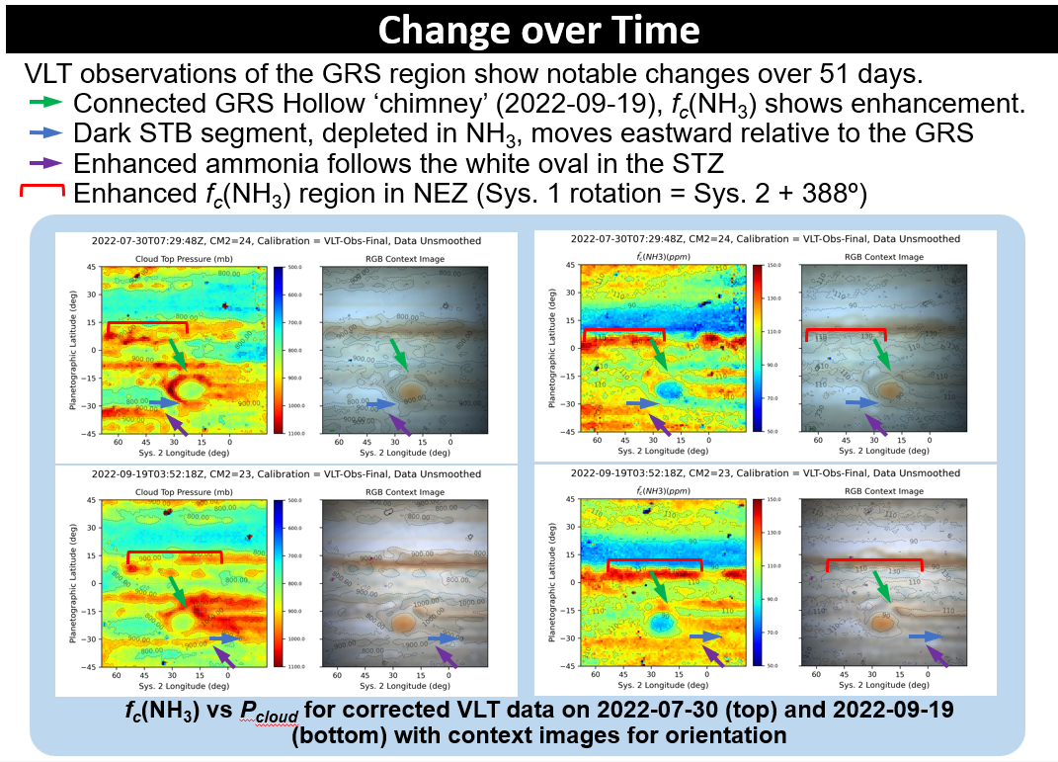

Figure : First 2022 change of time study from Hill et al., 2023 (AGU)

Table : GRS Candidate observations from 2022-23 (as of 11/28/2023). L2FITS.csv filtered for 340<CM2 or CM2<70 deg. Center Sys 2 Long = 25 deg.

|  |  |  |  |  |  |
| --- | --- | --- | --- | --- | --- |
| **ObsID** | **NH3 Time** | **CM1** | **CM2** | **CM3** | **Telescope** |
| 20220730UTa_Map | 2022-07-30_07:29:48 | 334.5 | 35.4 | 310.4 | VLT |
| 20220810UTa_Map | 2022-08-10_10:13:00 | 11.8 | 347.8 | 265.8 | C11 |
| 20220818UTa_Map | 2022-08-18_07:33:24 | 98.5 | 14.3 | 294.4 | C11 |
| 20220828UTa_Map | 2022-08-28_06:08:12 | 186.7 | 26.7 | 309.4 | C11 |
| 20220904UTa_Map | 2022-09-04_06:38:12 | 231.2 | 17.6 | 302.2 | C11 |
| 20220919UTa_Map | 2022-09-19_03:52:18 | 340.6 | 13.5 | 302 | VLT |
| 20220919UTb_Map | 2022-09-19_04:53:24 | 17.9 | 50.4 | 339 | C11 |
| 20221013UTa_Map | 2022-10-13_03:45:30 | 168.9 | 18.7 | 313.6 | C11 |
| 20221020UTa_Map | 2022-10-20_04:40:24 | 228.2 | 24.3 | 321.1 | C11 |
| 20230113UTa_Map | 2023-01-13_00:46:12 | 178.6 | 47.5 | 6.8 | C11 |

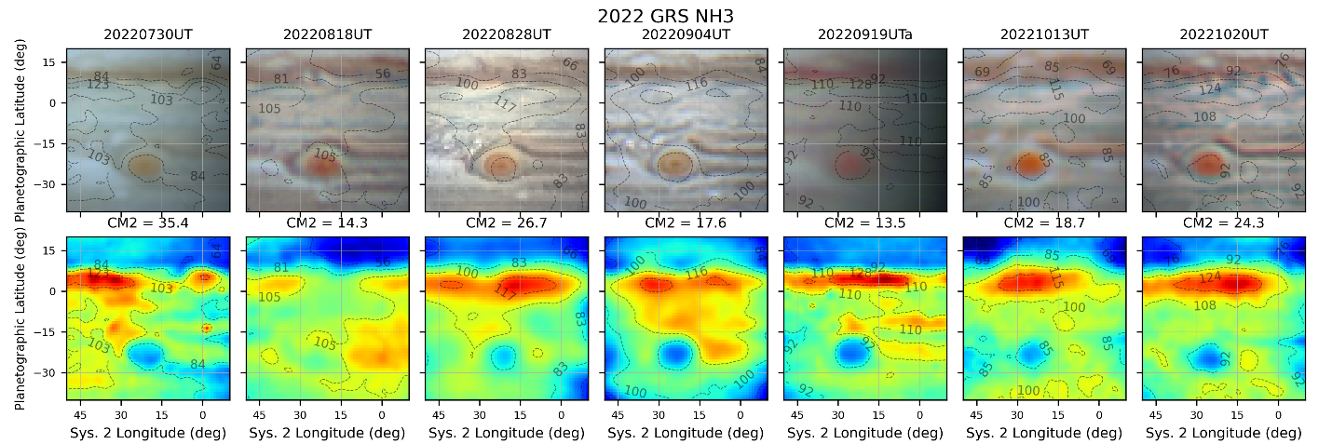

Figure : GRS_NH3_Comparison_2022.png computed by GRS_NH3_Comparison_2022.py

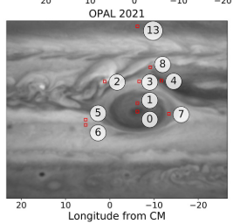

Figure : Study regions around GRS excerpted [Anguiano-Arteaga et al., 2023] (Fig 2)

Table : GRS Candidate observations from 2023-24 (as of 11/28/2023). L2FITS.csv filtered for 0<CM2<90 deg. Color bands have to do with collections of temporally close observation dates. Center Sys 2 long = 45 deg.

|  |  |  |  |  |
| --- | --- | --- | --- | --- |
| **ObsID** | **NH3 Time** | **CM1** | **CM2** | **CM3** |
| 20230831UTa_Map | 2023-08-31_11:30:42 | 130.4 | 40.9 | 61.5 |
| 20230831UTb_Map | 2023-08-31_11:53:42 | 144.4 | 54.8 | 75.4 |
| 20230905UTa_Map | 2023-09-05_11:38:18 | 204.8 | 77.1 | 99.1 |
| 20230924UTa_Map | 2023-09-24_11:48:48 | 333 | 60.2 | 87.2 |
| 20231005UTa_Map | 2023-10-05_04:59:54 | 21.8 | 27.3 | 57.2 |
| 20231015UTa_Map | 2023-10-15_04:56:36 | 160.1 | 89.3 | 121.9 |
| 20231017UTa_Map | 2023-10-17_05:05:42 | 121.8 | 35.6 | 68.7 |
| 20231017UTb_Map | 2023-10-17_05:33:12 | 138.5 | 52.2 | 85.4 |
| 20231022UTa_Map | 2023-10-22_04:11:12 | 158.7 | 34.7 | 69.2 |
| 20231103UTa_Map | 2023-11-03_03:53:24 | 244.3 | 28.9 | 66.5 |
| 20231110UTb_Map | 2023-11-10_04:06:18 | 278.4 | 9.4 | 48.9 |
| 20231110UTc_Map | 2023-11-10_04:32:06 | 294.1 | 25 | 64.5 |
| 20231113UTa_Map | 2023-11-13_02:31:42 | 334.7 | 43.4 | 83.7 |
| 20231113UTb_Map | 2023-11-13_02:59:24 | 351.6 | 60.2 | 100.4 |
| 20231115UTa_Map | 2023-11-15_03:21:24 | 321.1 | 14.2 | 55 |
| 20231115UTb_Map | 2023-11-15_03:47:54 | 337.2 | 30.2 | 71 |

# Meridional Profile Changes with Time

General changes between 2022 and 2023

Monthly changes(?) during 2023 if we have enough data

Look at not just time series spaghetti plots, but spaghetti plots versus longitude (Sys 1 and Sys 2)

Zonal profiles – look at airmass correction effectiveness

Related: Scatter plots – absorption versus airmass correction by band?

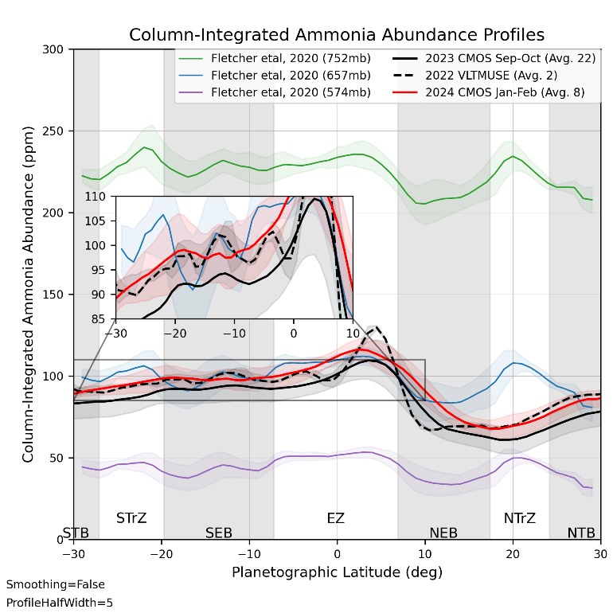 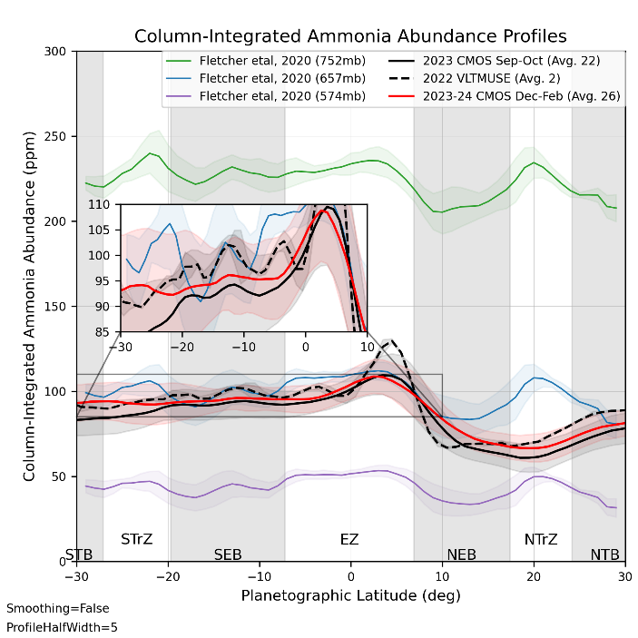

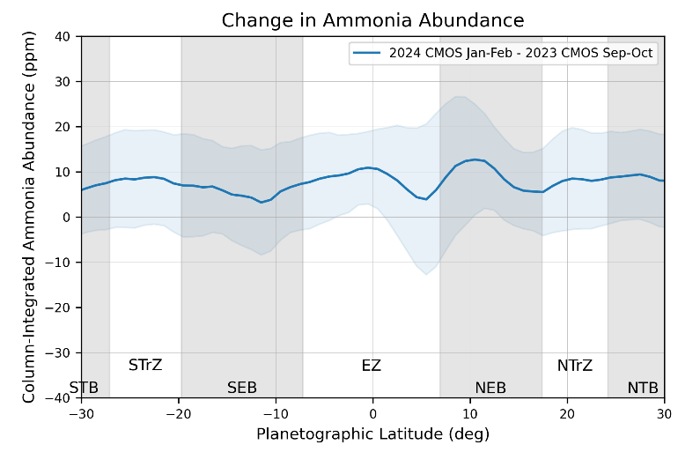 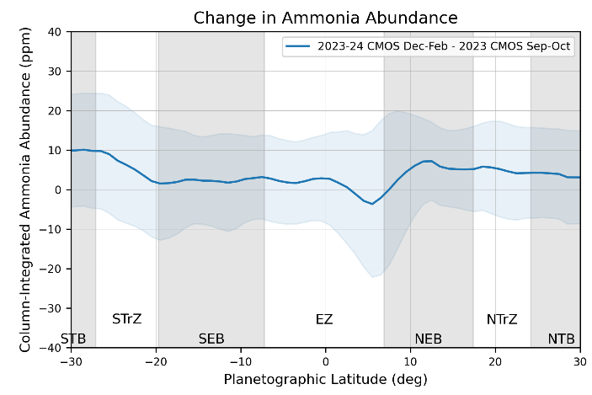

# Photometry

Complete 2023 moon photometry with CMOS and compare 2022 photometry with CCD

Tie 2023 photometry to stellar photometry.

This is going to be key for the cloud height determinations and reconciling VLT and SCT calibration

ISSUE: I should come up with better names for the plots created by my photometry software.

ISSUE: Make first attempt at 2024 calibration with CMOS data for moons and a standard star. This can be a throw-away in an Excel sheet.

# References

Anguiano-Arteaga, A., S. Pérez-Hoyos, A. Sánchez-Lavega, J. F. Sanz-Requena, and P. G. J. Irwin (2023), Temporal Variations in Vertical Cloud Structure of Jupiter's Great Red Spot, Its Surroundings and Oval BA From HST/WFC3 Imaging, *Journal of Geophysical Research (Planets)*, *128*, e2022JE007427, doi:10.1029/2022je007427.

Choi, D. S., A. P. Showman, A. R. Vasavada, and A. A. Simon-Miller (2013), Meteorology of Jupiter's equatorial hot spots and plumes from Cassini, *Icarus*, *223*, 832, doi:10.1016/j.icarus.2013.02.001.